Lab Exercise 18- Volume in Kubernetes Cluster

Volumes in Kubernetes provide a way to store and share data among containers in a Pod. This lab exercise will guide you through the creation and use of different types of volumes in Kubernetes.

Step 1: Set Up Kubernetes Cluster

Ensure you have access to a Kubernetes cluster. You can use a local setup with Minikube, kind, or use a cloud-based Kubernetes service.

Step 2: Create a Pod with an emptyDir Volume

Create a file named emptydir-pod.yaml with the following content:

apiVersion: v1
kind: Pod
metadata:
name: test-vol1
spec:
containers:
- image: nginx
name: test-container
volumeMounts:
- mountPath: /data
name: first-volume
volumes:
- name: first-volume
emptyDir: {}

In this manifest:

The emptyDir volume is a temporary storage that is created when the Pod is assigned to a node and exists as long as the Pod is running.

Apply the manifest to create the Pod:

kubectl apply -f emptydir-pod.yaml
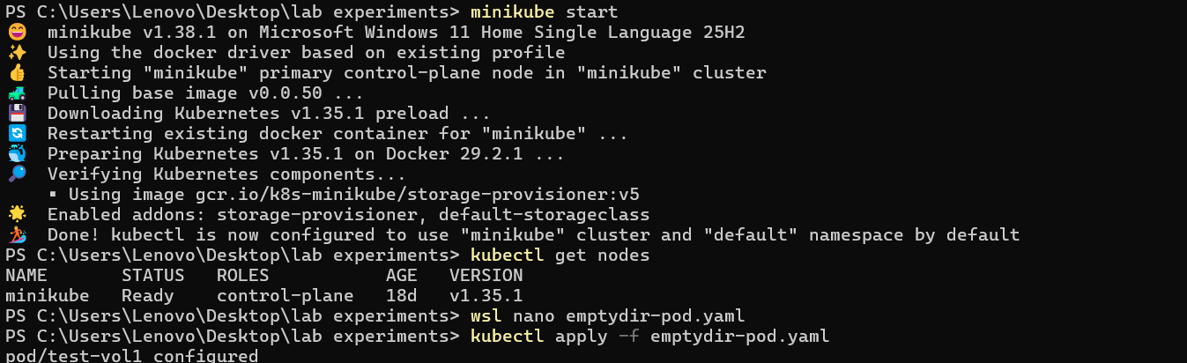

Step 3: Verify the Pod and Volume

Check the status of the Pod:

kubectl get pods

Access the Pod's shell:
kubectl exec -it test-vol1 -- bash

Inside the Pod, create a file in the /data directory:
touch f1 f2 f3

You should see the text "Hello, Kubernetes!".

Exit the Pod shell:
exit

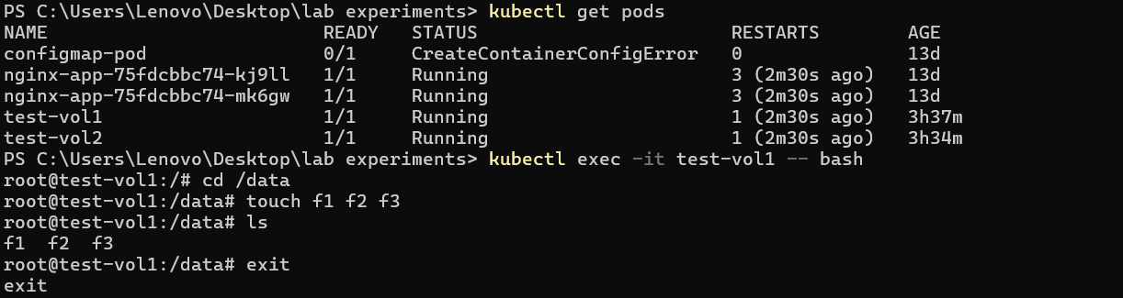

Step 4: Create a Pod with a hostPath Volume

Create a file named hostpath-pod.yaml with the following content:

apiVersion: v1
kind: Pod
metadata:
name: test-vol2
spec:
containers:
- image: coolgourav147/nginx-custom
name: test-container
volumeMounts:
- mountPath: /data
name: first-volume
volumes:
- name: first-volume
hostPath:
path: /test

In this manifest:

The hostPath volume mounts a directory from the host into the Pod at /mnt/data.
The busybox container writes the current date to a log file every 5 seconds.

Apply the manifest to create the Pod:

kubectl apply -f hostpath-pod.yaml
Step 3: Verify the Pod and Volume

Check the status of the Pod:

kubectl get pods
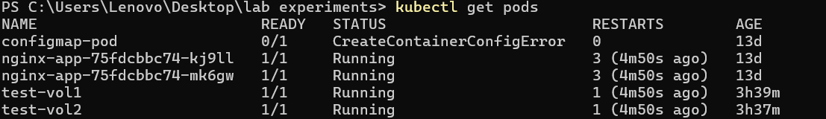
Access the Pod's logs to see the data being written:

kubectl exec -it test-vol2 -- bash

You should see the dates being appended to the log file.
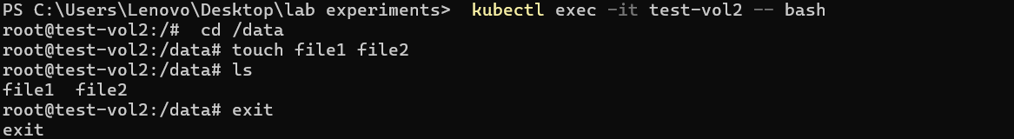

Check the host directory to verify the volume:

If you have access to the node running the Pod, you can verify the data in /tmp/data/log.txt.

